**CENWP-OD-B 12 July 2024**

**MEMORANDUM FOR THE RECORD**

**SUBJECT: 24BON025 MFR WA Shore AWS RB1 Pacific Lamprey Mortalities**

On the morning of 12 July 2024, Project Biologists discovered two Pacific Lamprey mortalities in Rest Box 1 of the Washington Shore Auxiliary Water Supply LPS (WA Shore AWS RB1). Both fish were inspected, measured, scanned for PIT tags, and returned to the river.

1. Species – Pacific Lamprey (*Entosphenus tridentatus*)
2. Origin – Unknown
3. Length – From left to right: 64.77cm, 71.12cm
4. Marks and tags – None
5. Marks and Injuries found on carcass – None, other than hemorrhaging from gill holes
6. Cause and Time of Death –Unknown
7. 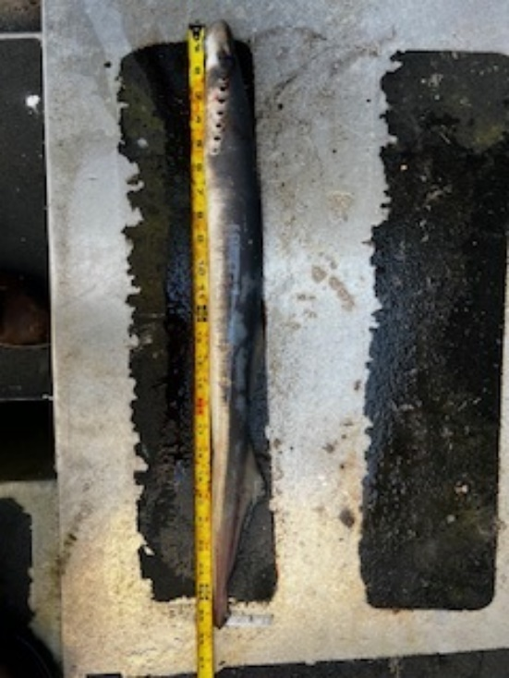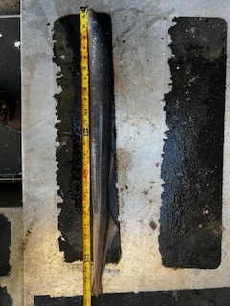Future and Preventative Measures – N/A

Sincerely,

Project Fisheries